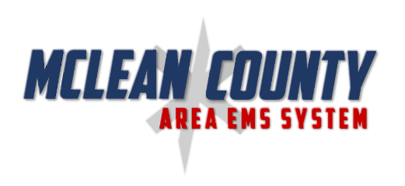

2020 Protocol Update Equipment Transition Plan

Medications
BLS | ILS | ALS
- Ibuprofen  - Benadryl  - Zofran  - Atrovent | - Ibuprofen  - Amiodarone  - D10W  - Benadryl (Tab)  - Zofran (ODT) | - Levophed  - Benadryl (Tab)  - Zofran (ODT)  - Ketamine  - Rocuronium
1/1/2020 | 1/1/2020 | 1/1/2020

Fluids
ILS | ALS
- Lactated Ringers | - Lactated Ringers
Replacement through expiration | Replacement through expiration

Other Equipment Supplies
BLS |  | ILS |  | ALS
Igel | As King Airway Expires | Adult Igel | As King Airway Expires | Adult Igel | As King Airway Expires
 |  | Pediatric Igel | 1/1/2020 | Pediatric Igel | 1/1/2020
PEEP Valve | 1/1/2020 | PEEP Valve | 1/1/2020 | PEEP Valve | 1/1/2020
 |  | System Approved Needle | 1/1/2020 | System Approved Needle | 50% of units by 6/1/2020  100% of units by 1/1/2021
 |  |  |  | Control Cric | 50% of units by 6/1/2020  100% of units by 1/1/2021
 |  |  |  | IV Pump | 4/1/2020
 |  | EZ-IO Bari Needle | 1/1/2020 | EZ-IO Bari Needle | 1/1/2020
2 tourniquets | 1/1/2020 | 2 tourniquets | 1/1/2020 | 2 Tourniquets | 1/1/2020

