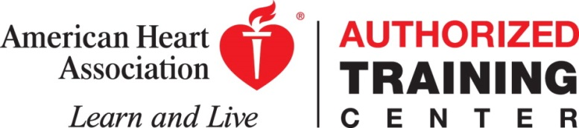

Advocate BroMenn Training Center
American Heart Association
BASIC LIFE SUPPORT (BLS) INSTRUCTOR COURSE
Day & Date: Saturday, March 2, 2019
Time: 9:00 a.m. (Lite Breakfast, coffee, water, & snacks will be served) to 1:00 p.m.
Location: Advocate BroMenn Medical Center
Conference Room #20 (New Tower – 2nd Floor)
1304 Franklin Ave., Normal, IL 61761

Fees: $350.00 - BLS Instructor Certification. Please find the course registration form attached. Once registration and payment have been received course materials and mandatory pre-course work will be ordered and mailed to the address provided on the registration form.

This course will certify you to teach American Heart Association (AHA) courses:
- BLS for Healthcare Providers, in addition to Heartsaver (HS) First Aid, HS CPR AED, HS First Aid with CPR AED, HS Bloodborne Pathogens, Family & Friends CPR, eLearning Skills Practice & Testing Sessions for BLS & HS (hybrid courses)

Instructor Candidate Prerequisite:
- Current Healthcare Provider card.
- Completed Instructor Candidate Application (Will be sent to you once registration form is received).
- Agree to teach at least 4 courses in a 2-year period.
- Be aligned with an AHA training center. Note: If you are not aligning with Advocate BroMenn Training Center a letter from the Training Center you are aligning with must be presented.
BLS Instructor candidates will receive one BLS Instructor Manual and one HS Instructor Manual. The course DVDs and equipment are not included. Equipment may be available for use from Advocate BroMenn Training Center. BLS course completion cards are $2.50 each and all Heartsaver completion cards are $17.00 each. Instructors are responsible for purchasing student manuals themselves for courses they teach.

Make checks for course payable to Janice Berlin
To register complete registration form and send with payment to:
Janice Berlin, Training Center Coordinator
2358 County Road 1100 N
El Paso, Illinois 61738
Registration deadline is February 15, 2019
*Contact Jan Berlin, AHA Regional Faculty, at (309) 268-5138 for any questions or concerns.

Advocate BroMenn Medical Center

BLS Instructor Course Registration Form

Name: __________________________________________________

Address: ________________________________________________

________________________________________________

Home Phone: ____________________________________________

Cell Phone: _____________________________________________

Work Phone: ____________________________________________

Email Address: __________________________________________

Please attach copy of current BLS (Healthcare Provider) Card

Mail form and payment to:
Janice Berlin, AHA Regional Faculty
2358 County Road 1100 N
El Paso, Illinois 61738

REGISTRATION DEADLINE February 15, 2019

