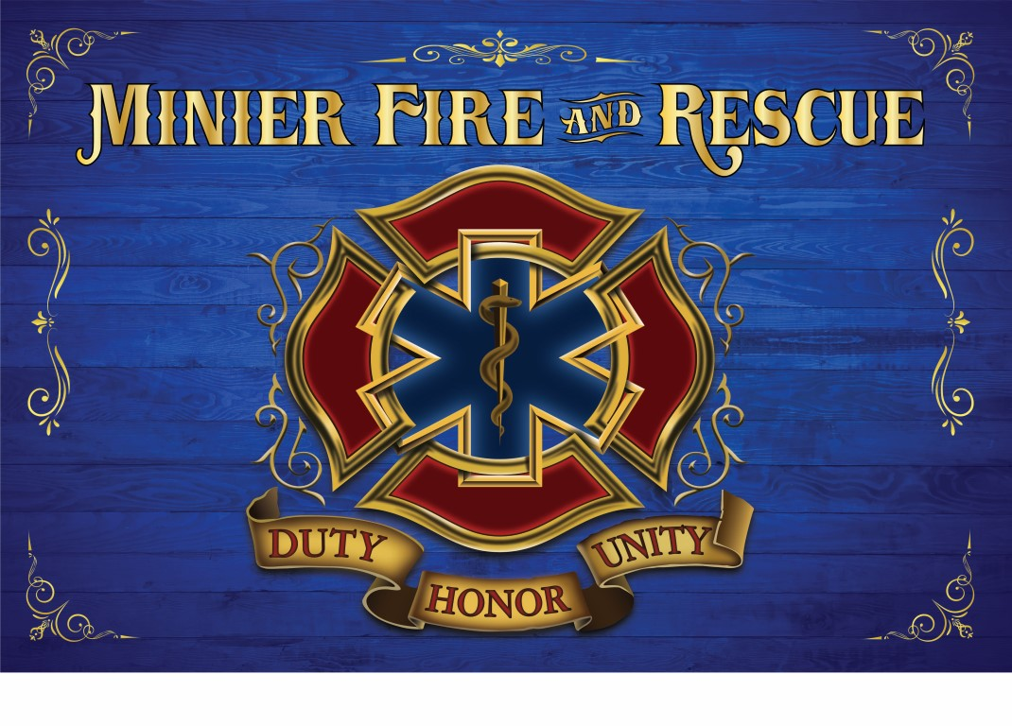
Minier Rescue Hiring EMT-Bs
- Must be a member of the McLean County Area EMS System (or be able to test into the system).

Send Inquiries/resumes to:
Minierems@gmail.com

